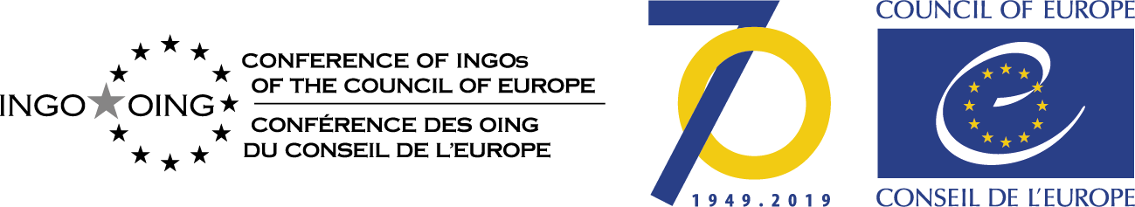

Declaration

The representatives of INGOs with participatory status with the Council of Europe present to the HR Committee meeting on 28.10.2019 declare:

We are outraged to note that Turkey, a Council of Europe (CoE) member state, and for many a NATO partner, has launched an invasion (Operation Peace Spring) in Northeast Syria, aiming "to prevent the creation of a terror corridor across the southern border, and to bring peace to the area" by creating a 32km (20-mile) deep "safe zone" running for 480km (300 miles) along the Syrian side of the border.

It is the observation of the Human Rights Committee that the so-called terror corridor was in fact an area where Kurds (the People's Protection Units (YPG)) - who helped to defeat Daesh - in alliance with local Arab militias called the Syrian Democratic Forces (SDF) vested an area where Rule of Law, Democracy and Human Rights were observed. An area where all minorities were cooperating in the public administration and where gender equality was a basic feature.

We note further that, when the Turkish offensive began, the UN said the potentially affected area was home to 2.2 million people, including 1.3 million in need of humanitarian assistance, and two government-controlled cities where 450,000 people live - Qamishli and Hassakeh.

Furthermore, we understood that Turkey also aimed to resettle, in the zone, up to two million of the 3.6 million Syrian refugees it is hosting.

Turkey as a Council of Europe member State and the United-States, as an observer State, should not be involved - either actively or passively - in ethnic cleansing and mass displacement of people, for example by relocating refugee camps to the current disputed zone with the clear intention of to disadvantage the Kurds present in their claims regarding land and autonomy.

The INGOs reiterate that the ECtHR is applicable everywhere where a Member State has jurisdiction (de jure and the facto). This includes territories which Turkey effectively controls now.
We urge
All involved parties to immediately broker a lasting peace in this region, which can only be the result of a consultation of all groups present in the contested area (Kurds and Arab, Christian and other allies), not forgetting to involve NGOs and women in the peace process
All Council of Europe member States
to repatriate and put to trial suspected IS fighters of its own nationality, and bring their woman and children and physically or mentally impaired persons in safety.
to send immediately humanitarian and emergency aid to population of the troubled region, using the expertise of NGOs, observer’s / monitoring organizations, especially those that focus on protecting children, elderly, physically or mentally impaired, women.

UN Security Council Resolution 1325 on Women and Peace and Security

